Neural Network and Deep learning: Assignment -5

Vishnu Teja Ayyangar Nallan Chakravartula

700746150

GitHub: [https://github.com/vishnutejaayyangar/ICP5](NN-Assignment5%20(2).docx)

Video Link: <https://drive.google.com/drive/u/3/folders/1k9LVIr7pGjDOGpV2-r4H34FuMYqHJXtc>

1. Import the Sentiment dataset from google drive.

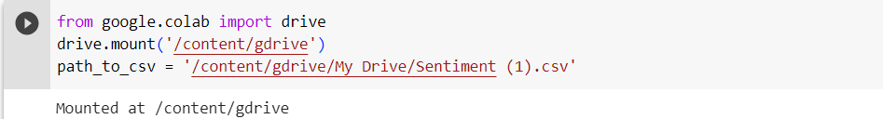

1. Import all the required basic packages and libraries.

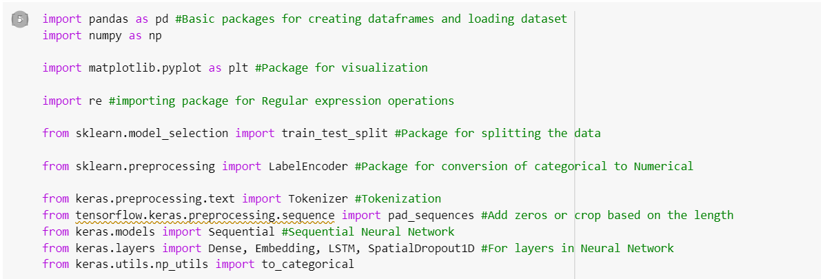

1. Load the data and keep only necessary columns 'text' and 'sentiment' contains the corresponding sentiment labels ('positive', 'negative', or 'neutral').

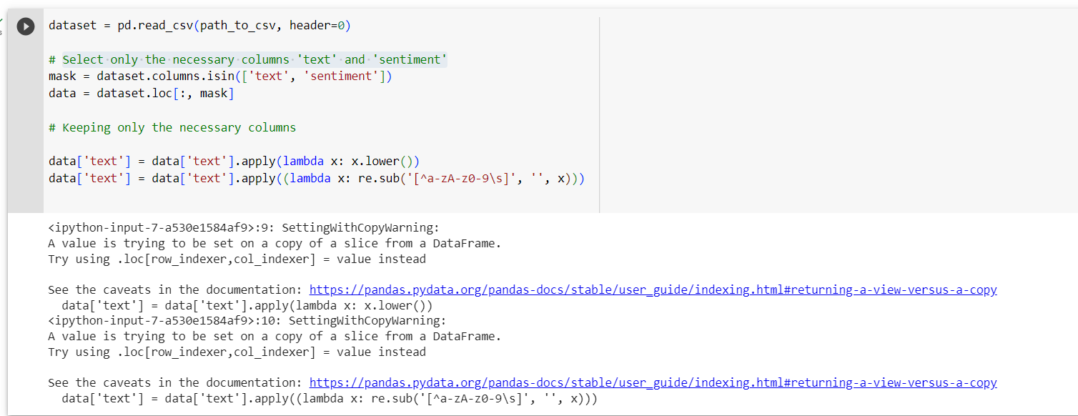

1. 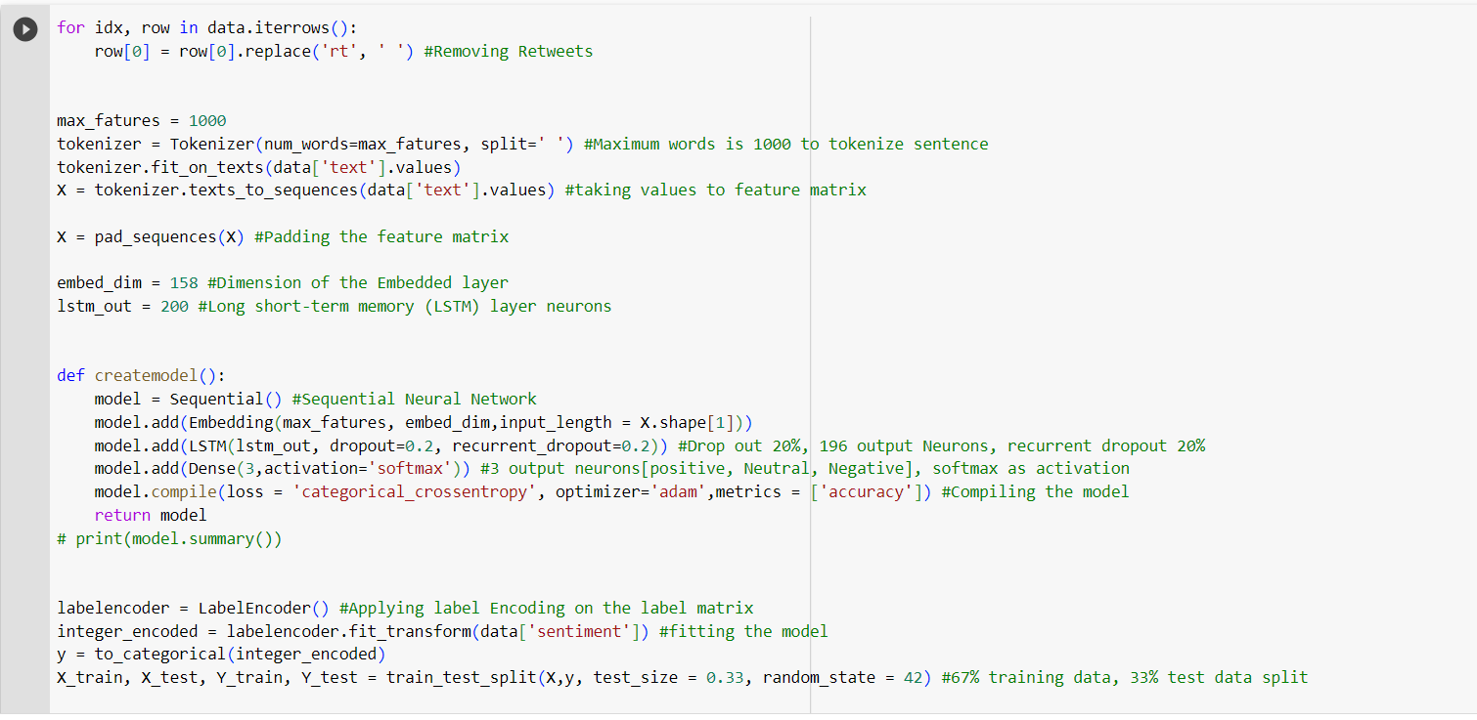
2. 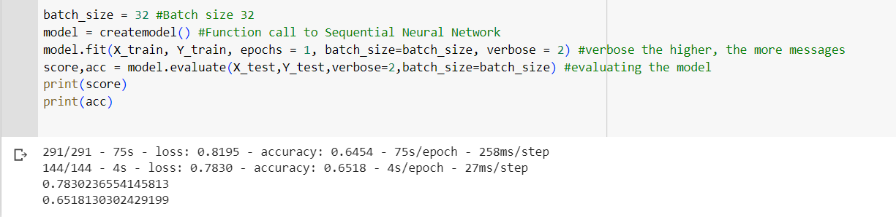
3. 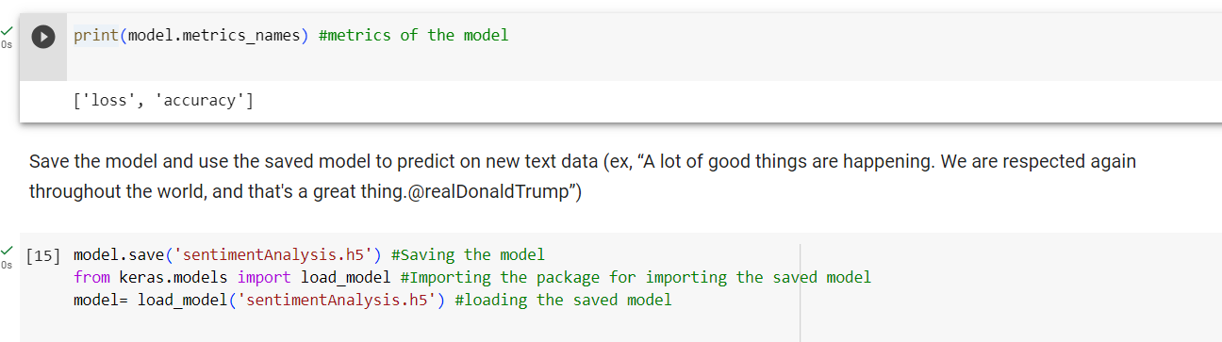

**Save the model and use the saved model to predict on new text data (ex, “A lot of good things are happening. We are respected again throughout the world, and that's a great thing.@realDonaldTrump”)**

1. Save the model and use it to predict on new text data

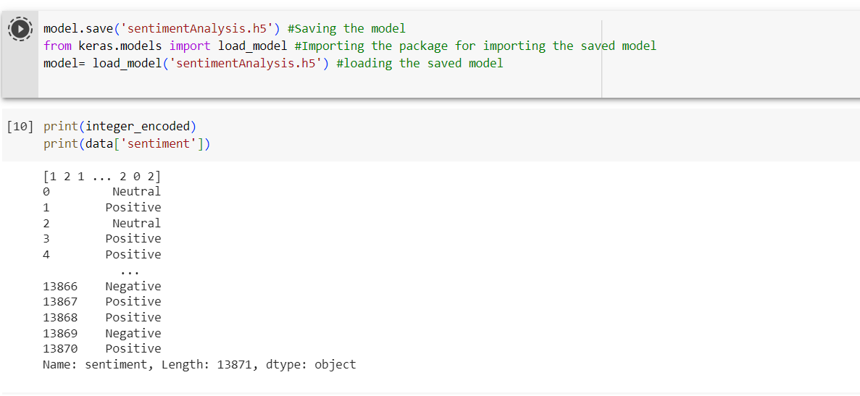

Predicting the text data

1. 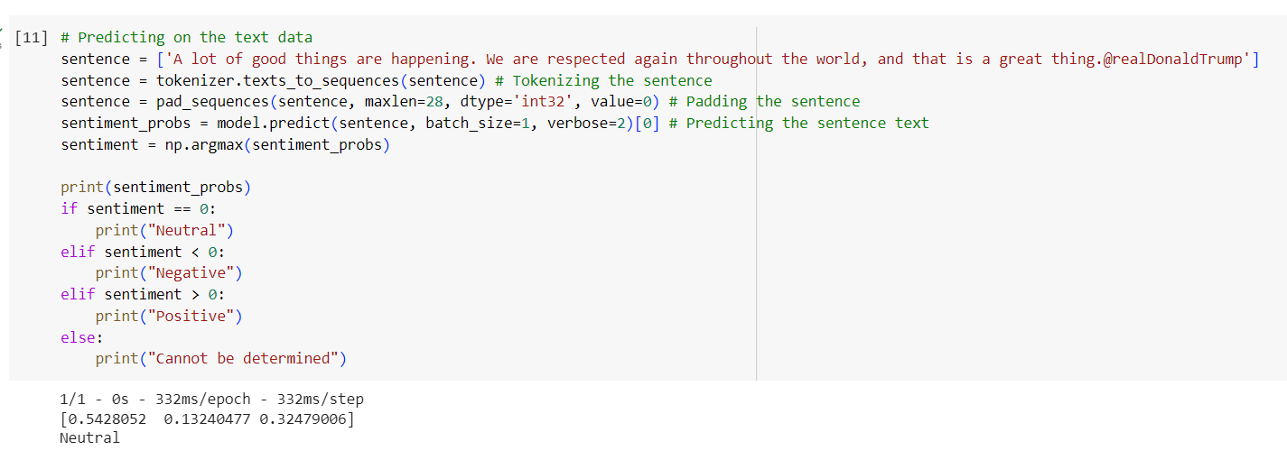
2. Applying the grid search on the code provide in the class

